Hospitality Management Association
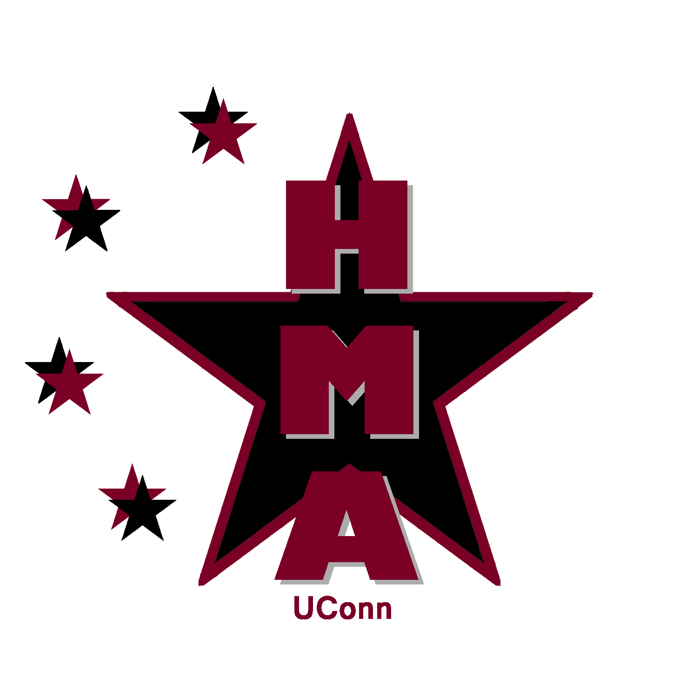
Meeting Minutes

09.05.2011
Phillips Communication Sciences Building
Second floor conference room
6pm-7:35pm

HMA's website
- Gao will contact Eboard for bio and photo to upload on website. Navi will give Gao access to HMA gmail account.
- Navi will send out email to members to send resources to Amanda and contacts to Kate

HMA's online Calendar
- http://web2.uconn.edu/wdlcalendar/index.php/week/2011-09-03/All/All/Hospitality_Management_Association1/
  - Kate Byrne is administrator and approves event submissions
  - Calendar link to be emailed to members and included on Facebook page and HMA website. (Navi)

Facebook Group Page
- Navi will create Facebook group page. Secretary will be in charge of maintaining page and sending out meeting reminders as messages to group members.

HMA's email
- Greg will add new members to contact list (those students who signup at involvement fairs) and let Karolina know when he is done, Navi will email him contact info for HMA gmail account.
- Navi will send email new freshmen who won the raffle for free yearly membership to HMA
- Navi and Secretary in charge of checking and replying to emails.
- Secretary will send out reminders for meetings with agendas and follow up after the meetings with the Meeting Minutes
  - Navi will email secretary account info for HMA gmail account.

Membership/Materials/Requesting Funds
- Han Hu won the free raffle membership from orientation. Two other winners will be chosen after the involvement fair for free membership as well. Navi will email them and thank everyone else who entered for their interest in HMA and let them know of upcoming meetings. They will also be added to email list.
- Karolina will create spreadsheet to keep track of collected due and contact USG for funding information. Will keep us posted.
- Dues: $15 for the year, $10 for the semester.
- Refreshments will be provided at meetings, Kate and Navi will arrange to pick up refreshments.

School of Business (SB) involvement Fair
- Ailish created a posted, Navi will set up the table with the fliers and posters. Gao and Anita are the first scheduled to maintain the table at 3pm.
- 3-3:30 Anita Chu and Gao Cai
- 3:30-4 Ailish Keating and Kate Byrne
- 4-4:30 Ailish Keating and Kate Byrne
- 4:30-5 Kate Byrne and Khoi Vo (Jessica Nadeau??)
- Kate will pick up materials and bring to University Involvement fair the next day.

University Involvement Fair
- Navi will register HMA at 12pm
- 2-3 Kate Byrne
- 3-3:30 Jeffrey Lecours
- 3:30-4 CT Narayanan
- 4-5 Ailish Keating and CT Narayanan
- 5-6 Ailish Keating and Navi Cheema
- 6-7 Navi Cheema
- Navi will get new contacts to Greg so he can update the contact list on the HMA contact list. Greg will let Karolina know when he is done so Karolina can create a spreadsheet to keep track of collected dues.
- Will also select two new members as raffle winners for free year membership. (Navi will send email announcing winners)

First member meeting
- Monday, September 12th from 6-7pm
- Room is being determined, most likely BUSN 227
- Secretary will create agenda and email to members the night before. Secretary will also record the meeting minutes and email to members after the meeting.
- Refreshments will be provided
- Lauren will create a sign up sheet for new members who show up

THINGS TO PUT ON NEXT AGENDA:
- Communicating with guest speakers
  - Contact list to Kate Byrne. Kate and event managers will start planning meetings and events.
- Proper attire for meetings.
  - Suggest business casual for general meetings.
  - Mandatory business casual when have guest speakers
  - Mandatory business casual for eboard
- FSBC visit
- Business Open House
- Kate will discuss upcoming plans for meetings. Talk to her event managers…
- Possible opening of secretary

